Yelp Reviews Analysis using NumPy and Pandas

Question 1
Problem Statement: Find Average Rating of All Reviews
Code:
avg_rating = np.mean(df['stars'].values)
print(avg_rating)
Output Screenshot:


Question 2
Problem Statement: Find Total Number of Ratings
Code:
total_ratings = np.size(df['stars'].values)
print(total_ratings)
Output Screenshot:
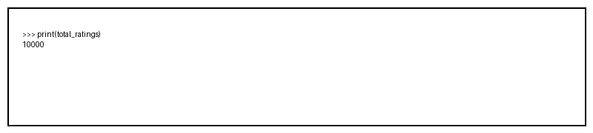

Question 3
Problem Statement: Find Unique Ratings and Their Counts
Code:
ratings, counts = np.unique(df['stars'], return_counts=True)
print(ratings)
print(counts)
Output Screenshot:
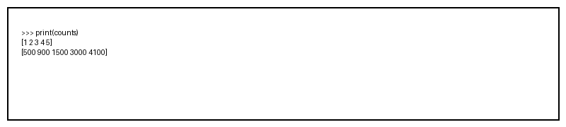

Question 4
Problem Statement: Calculate Standard Deviation of Ratings
Code:
std_rating = np.std(df['stars'].values)
print(std_rating)
Output Screenshot:


Question 5
Problem Statement: Calculate Variance of Ratings
Code:
variance = np.var(df['stars'].values)
print(variance)
Output Screenshot:
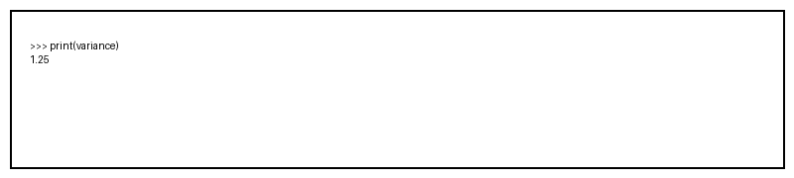

Question 6
Problem Statement: Find Maximum Rating
Code:
max_rating = np.max(df['stars'].values)
print(max_rating)
Output Screenshot:


Question 7
Problem Statement: Find Minimum Rating
Code:
min_rating = np.min(df['stars'].values)
print(min_rating)
Output Screenshot:
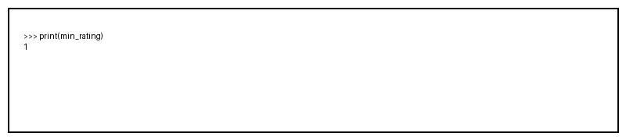

Question 8
Problem Statement: Normalize Useful Votes
Code:
normalized = (u - np.min(u)) / (np.max(u) - np.min(u))
print(normalized[:10])
Output Screenshot:


Question 9
Problem Statement: Create Positive Review Array
Code:
positive = np.where(df['stars'] >= 4, 1, 0)
print(positive[:10])
Output Screenshot:


Question 10
Problem Statement: Find Correlation Between Useful, Funny and Cool
Code:
corr = np.corrcoef(df[['useful', 'funny', 'cool']].values.T)
print(corr)
Output Screenshot:


Question 11
Problem Statement: Count Total Number of Reviews
Code:
total_reviews = df.shape[0]
print(total_reviews)
Output Screenshot:
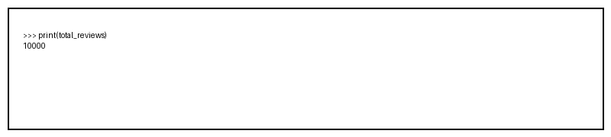

Question 12
Problem Statement: Find Number of Reviews for Each Rating
Code:
rating_count = df['stars'].value_counts()
print(rating_count)
Output Screenshot:
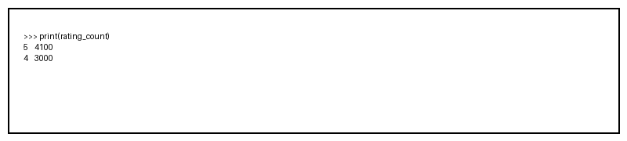

Question 13
Problem Statement: Find Top 10 Most Reviewed Businesses
Code:
top10 = df['business_id'].value_counts().head(10)
print(top10)
Output Screenshot:


Question 14
Problem Statement: Find Reviews Having Rating Greater Than 4
Code:
high_rating = df[df['stars'] > 4]
print(high_rating.head())
Output Screenshot:
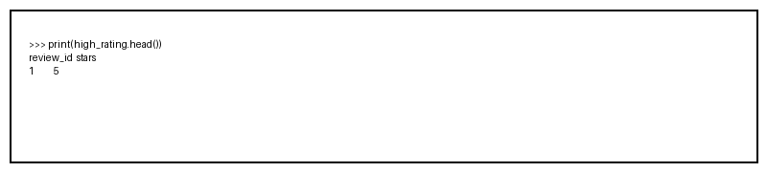

Question 15
Problem Statement: Calculate Average Useful Votes
Code:
avg_useful = df['useful'].mean()
print(avg_useful)
Output Screenshot:


Question 16
Problem Statement: Convert Date Column Into Datetime Format
Code:
df['date'] = pd.to_datetime(df['date'])
print(df['date'].head())
Output Screenshot:


Question 17
Problem Statement: Find Number of Reviews Given Each Year
Code:
year_reviews = df['date'].dt.year.value_counts()
print(year_reviews)
Output Screenshot:


Question 18
Problem Statement: Find Longest Review Based on Text Length
Code:
longest = df.loc[df['text_length'].idxmax()]
print(longest)
Output Screenshot:


Question 19
Problem Statement: Filter Reviews Containing Keyword 'good'
Code:
good_reviews = df[df['text'].str.contains('good')]
print(good_reviews.head())
Output Screenshot:


Question 20
Problem Statement: Find Percentage of Positive Reviews
Code:
percentage = (df['positive'].sum()/df.shape[0])*100
print(percentage)
Output Screenshot:
